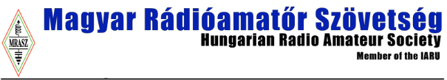

8th World Youth ARDF Championships
July 1 - 5 Veszprém Hungary

LETTER OF INTENT

We,_______________________________________________
(Name of the society)
_________________________________________________
(Abbreviation)
Hereby express our intention to participate in the 8th World Youth ARDF Championship, July 1-6, 2026, Veszprém, Hungary.

1. The expected number of team members:
Competitors (up to 5 in each category):
W14: ________ M14: ________W16: ________M16: _______persons. Officials, Visitors etc (unlimited number): ______________ persons.
Total: _________________________persons.

2. Team contact person:
Name: _____________________________________________
Phone: _____________________________________________
E-mail: ______________________________________

Deadline for the letter of intent –March 01, 2026.
Please, send the letter of intent by e-mail to: wyac2026@ardf.hu

